**[[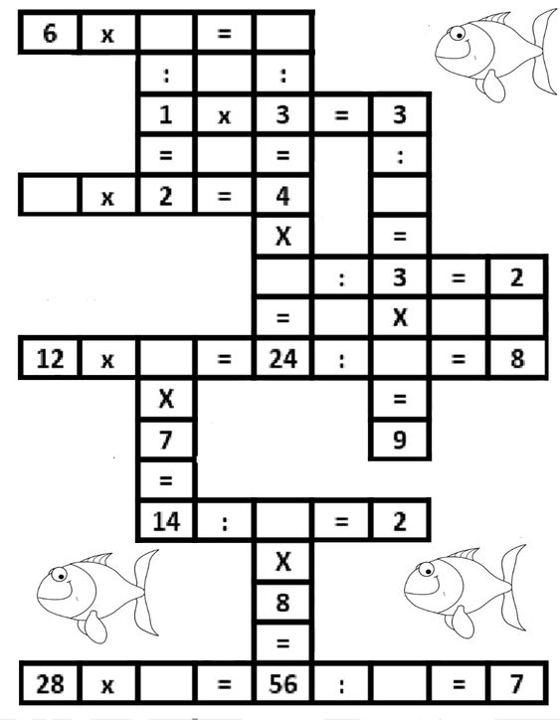](https://chicago-lawyer-attorney.blogspot.com/2019/08/grade-3-multiplication-crossword.html)](https://chicago-lawyer-attorney.blogspot.com/2019/08/grade-3-multiplication-crossword.html)**