

**Present Continuous**

He is eating now.

He is not eating now.

Is he eating now?





They are singing.

_____________________________

_____________________________________ ?

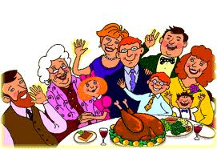

They are celebrating.

_____________________________

_____________________________________ ?

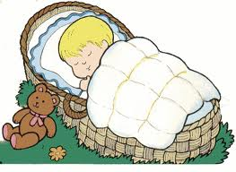

The baby is sleeping.

_____________________________

_____________________________________ ?

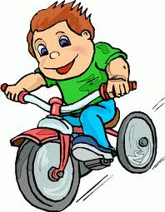

He is riding a bike.

_____________________________

_____________________________________ ?

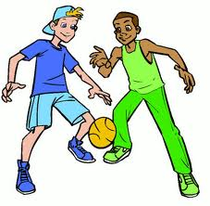

They are playing.

_____________________________

_____________________________________ ?



It is raining now.

_____________________________

_____________________________________ ?

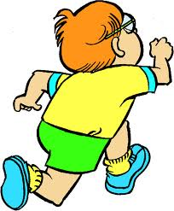

He is running.

_____________________________

_____________________________________ ?





He is running.

_____________________________

_____________________________________ ?

He is running.

_____________________________

_____________________________________ ?

He is running.

_____________________________

_____________________________________ ?