**[[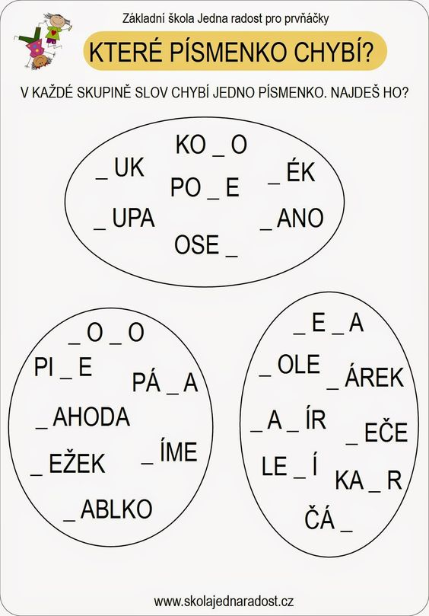](http://tridamagdy.blogspot.com/p/pracovni-listy.html)](http://tridamagdy.blogspot.com/p/pracovni-listy.html)**