**[[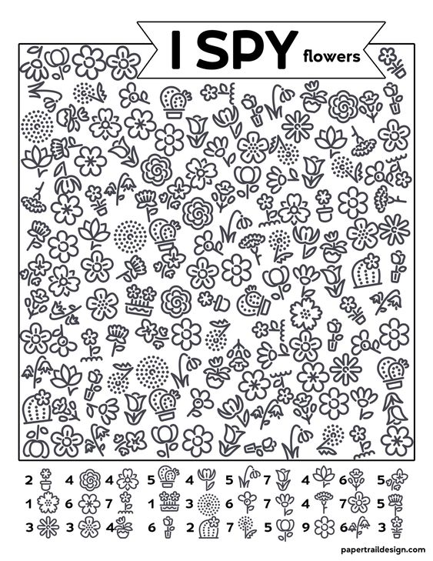](https://www.papertraildesign.com/free-printable-i-spy-flowers-activity/)](https://www.papertraildesign.com/free-printable-i-spy-flowers-activity/)**