5. 10. Zeměpis 9. tř. EU member states and members of eurozone. Revision . worksheet.
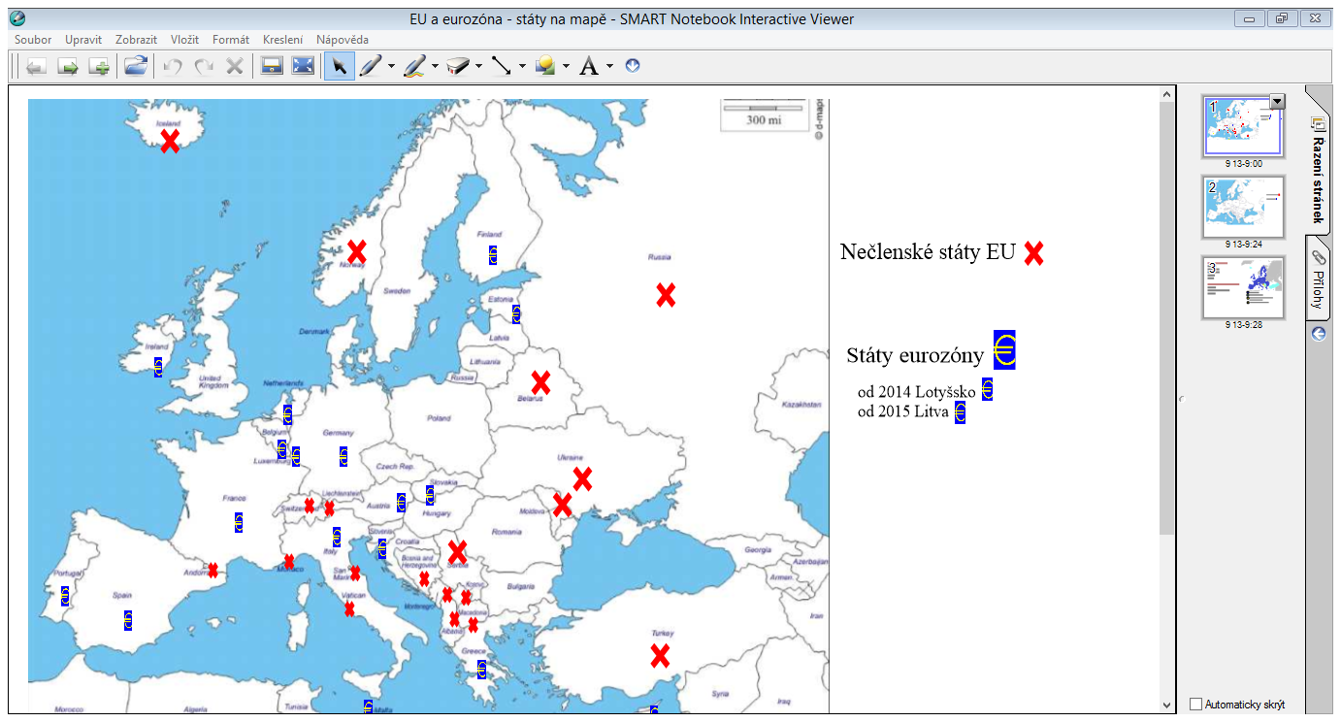

Pracovní list na opakování
1 Colour in the EU flag.
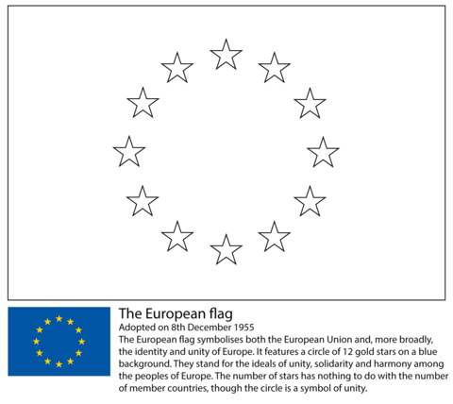

2 Answer these questions:
- What is the name of EU anthem and who is its author? In which picture is he?
…………………………………………………………………..………………………………
A 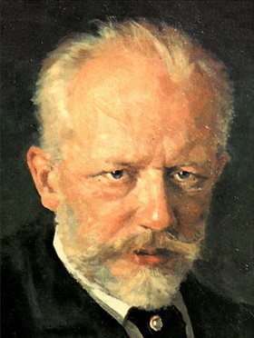 B 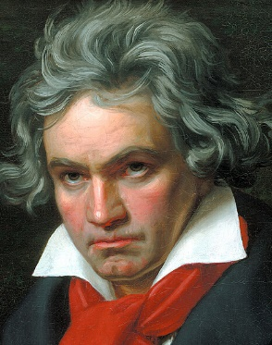 C 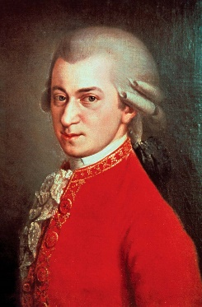 D 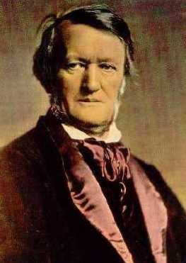
- How many members does the EU have?
…………………………………………………………………………..………………………
- The motto of the EU first came into use in 2000. Can you write it?
………………………………………………………………………………………………….
3 Fill in the cities /towns – seats of the EU institutions
- the European Parliament - …………………………………………. Strasbourg, Brussels
- the European Council - …………………………………………….. Brussels
- the Council of the European Union - ……………………………… “
- the European Commission - ………………………………………. “
- the Court of Justice of the European Union - ……………………. Luxembourg
- the European Central Bank - ………………………………………. Frankfurt
- the Court of Auditors - ………………………………………….. Luxembourg

Non-EU member states
eurozone (euro area) member states

Eurozone participation
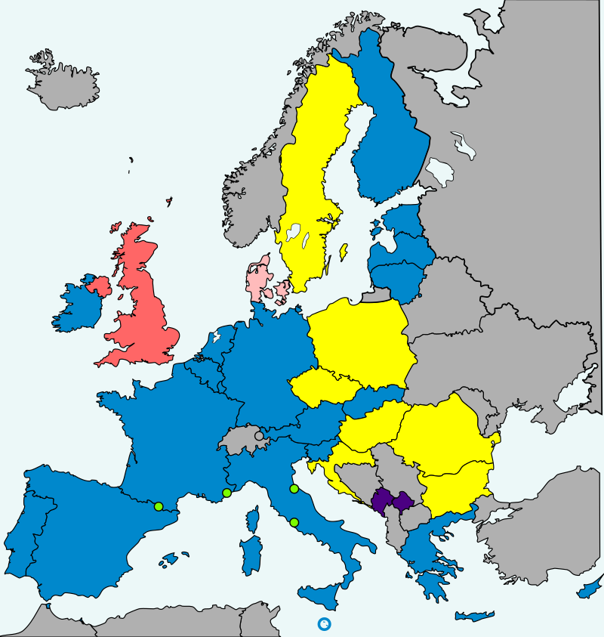
European Union (EU) member states
19 in the eurozone.
7 not in ERM II, but obliged to join the eurozone on meeting convergence criteria (Bulgaria, Croatia, Czech Republic, Hungary, Poland, Romania, and Sweden).
1 in ERM II, with an opt-out (Denmark).
1 not in ERM II with an opt-out (United Kingdom).
Non-EU member states
4 using the euro with a monetary agreement (Andorra, Monaco, San Marino, and Vatican City).
2 using the euro unilaterally (Kosovo^{[a]} and Montenegro).

Facts of Europe, EU member states, our country

Europe European Union Your country
Number of countries/name 28 47 (incl. Kosovo) Czech Republic
Area 10, 180, 000 km² 4, 475,757 km² 78, 866 km²
Population 742,250,955 513,481,691 10, 649, 800
Density 117/km² 73/ km² 134/km²
HDI 0,845 0,899 0,888
HDI = Human Development Index

You can find more information on: europa.eu

